**AWS**

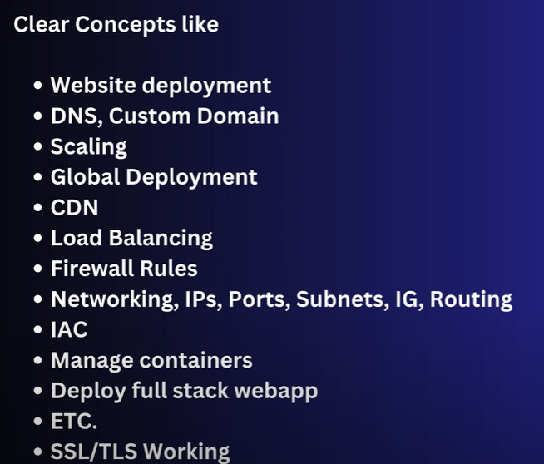

From the video these topics will be cleared

What is virtualization:

Suppose you created a software in your window OS and now you want to run software on MacOS, ubuntu. For that you need to buy new setup and installed required OS.

By **Virtualization** you can works on any OS in your laptop. It created a virtual machine on top of your system run on same or different OS. This can be done using the help of **hypervisor**.

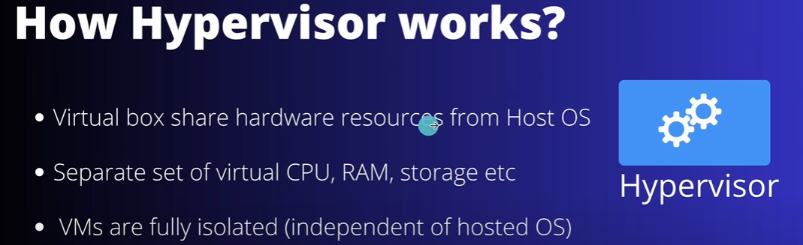

Eg of hypervisor:

vitualbox(open source), ...

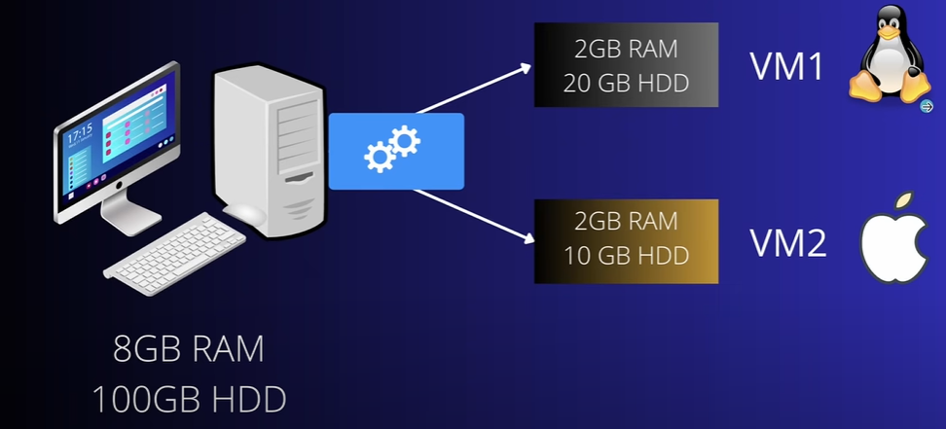

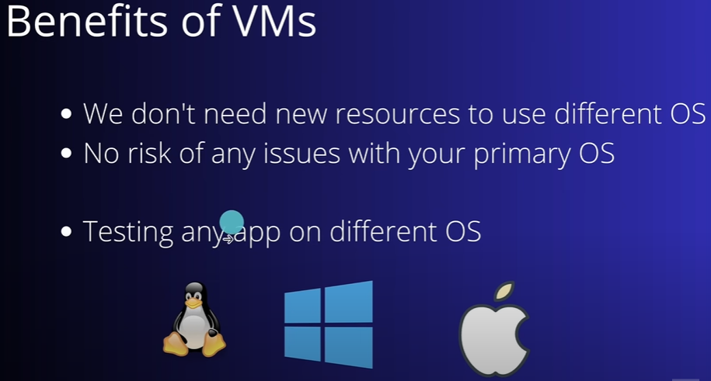

Cloud Computing:

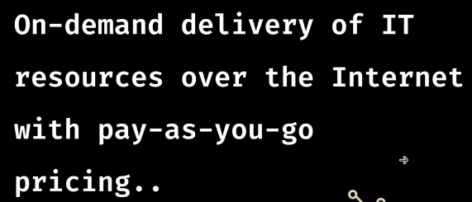

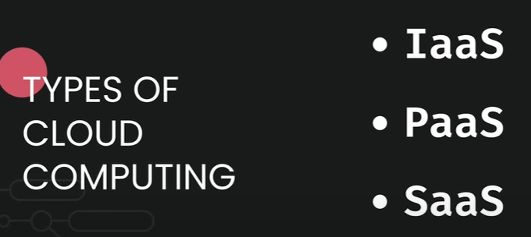

IaaS:

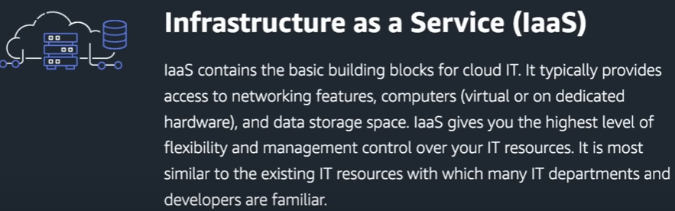

Lets understand IaaS using an example. Suppose you want to open icecream parlour. You rented a empty space in amy mall after that you have to arrange machine, table, chair, staff and many all so. This will provide flexibilty to design according to you requirement but all have to many by yourself.

PaaS:

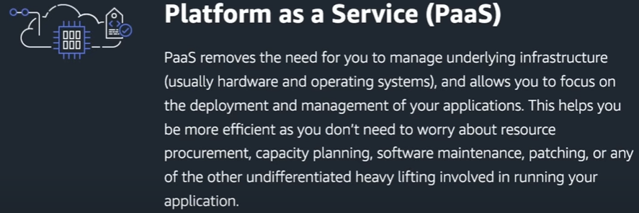

Use same eg of icecream parlour, now you have machine, table chair. You just need to make ice cream and then sell it.

SaaS:

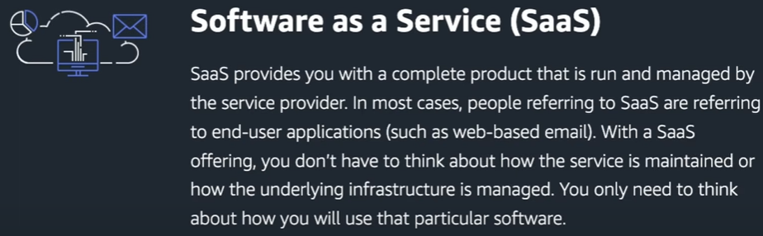

Here we can use icecream vending machine where cutoer can select any type of icecream.

In software terms, For Msexcel we need to install in our system to use it, But now we can use googlesheet virtually using browser which is basically Saas, we are just using the service.

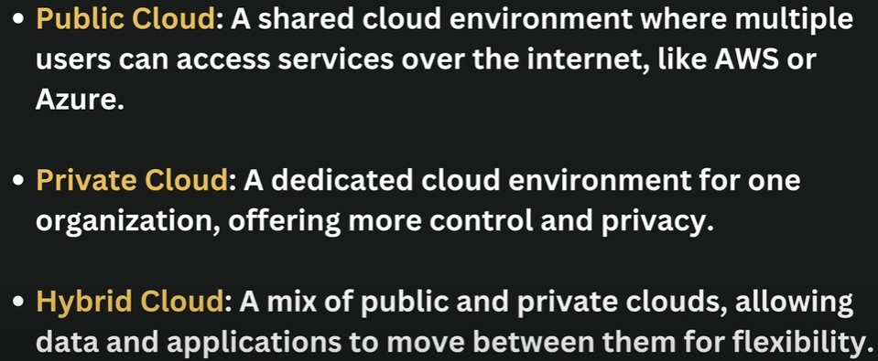

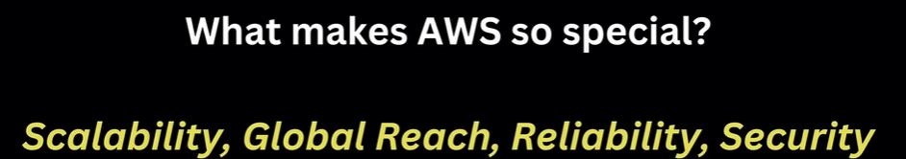

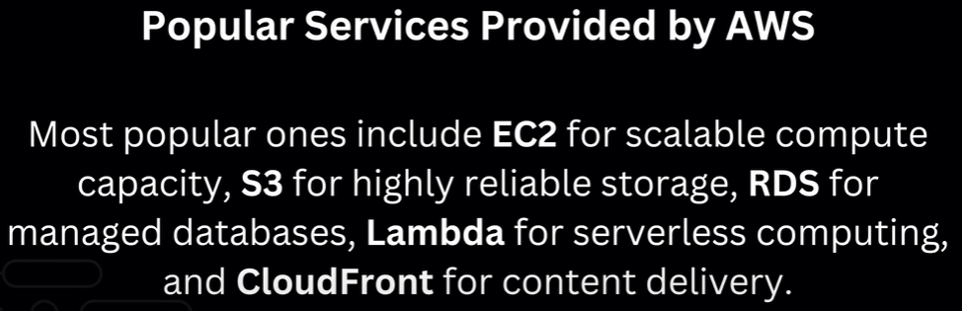

**AWS IAM:**

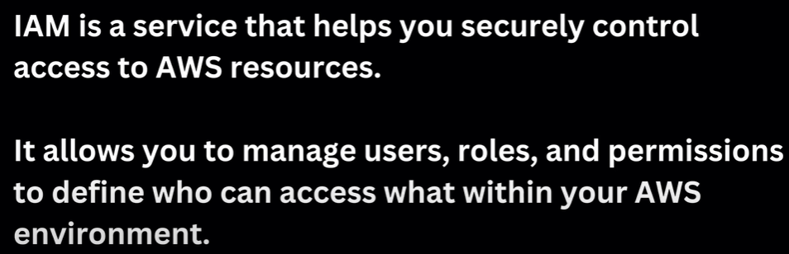

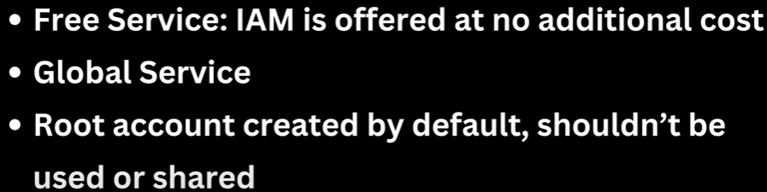  
  
It is a global service means it doesnt required any region for this service, it will work for all the regions due to this it is global service

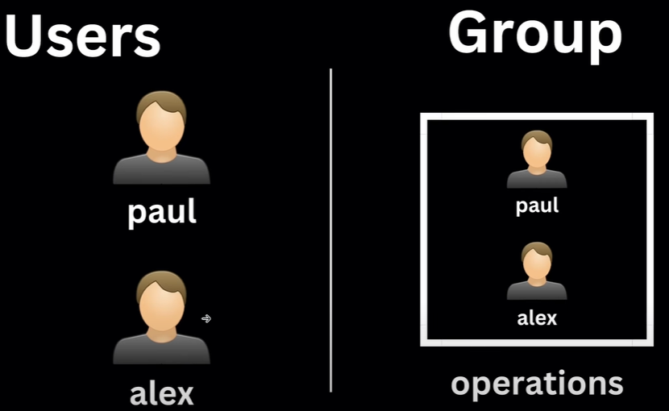

Here you can set permisson to indiviuals or create a groups with permisson and store users under that groups to get all premisson associated with groups

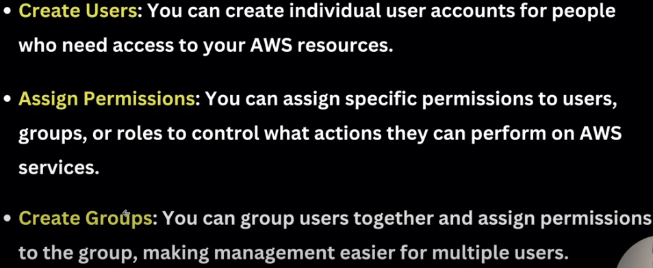

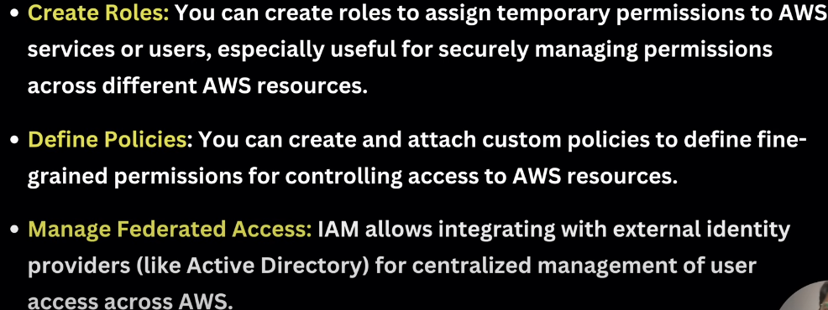

**MFA:** Provide extra security to a user.

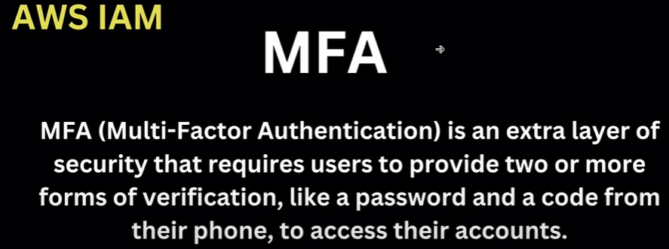

**Multiple ways to access AWS service:**

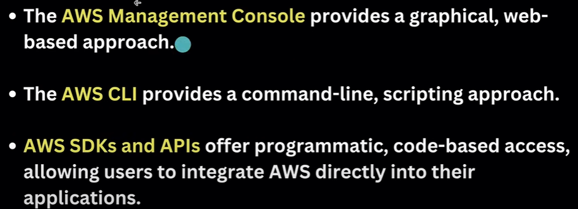

From third point we can access the aws service by writing code to integrate with AWS.

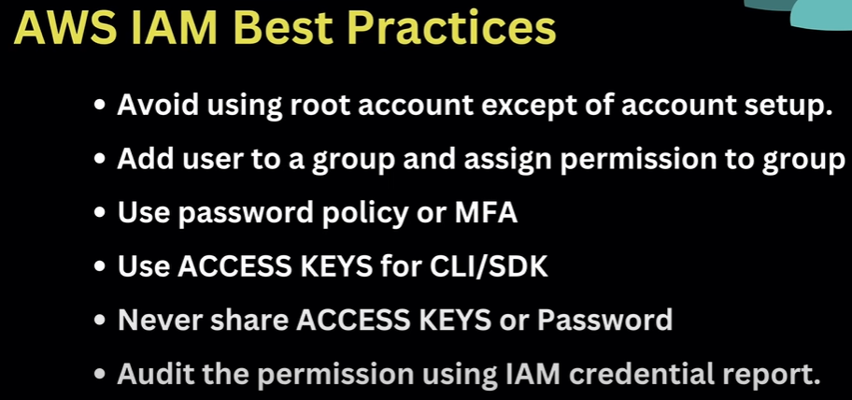  
  
Acces key and secret is also in CLI and SDK to access to aws service. i.e., we mention access key and secret in springboot application to access any AWS service

**AWS EC2:**

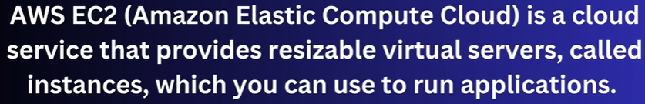

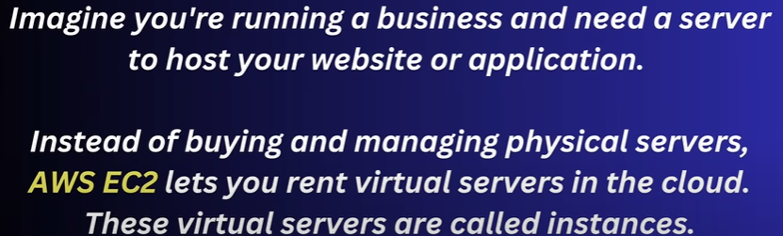

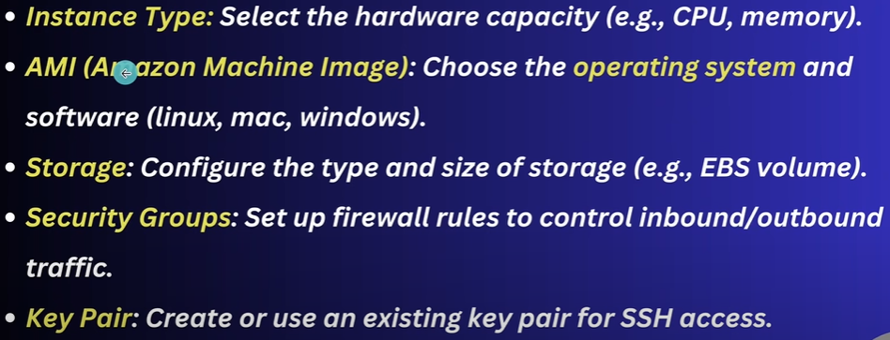

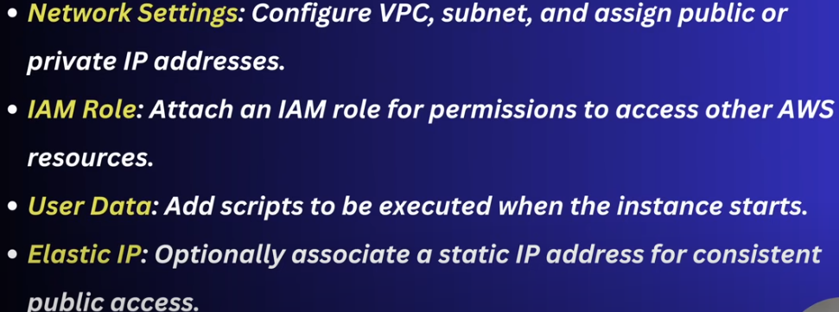

EC2 instance is a region specific service means if you can region in aws console then you will not see ec2 instance which you created.

We have **key-pair** while create instance, this is used to connect to your virtual server from your computer.

**Security groups:**

It is a firwall which control the traffic to access to your server, like from this region user only access my server.

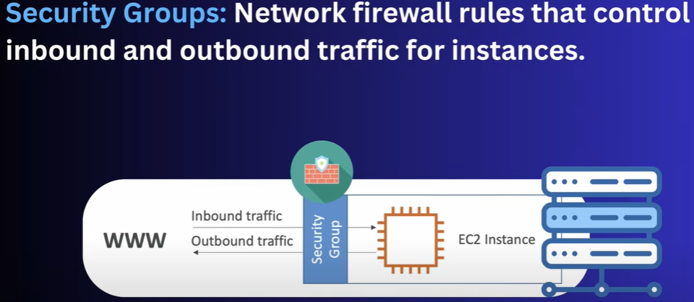

**Port 80 is for http**

**Port 22 is for ssh**

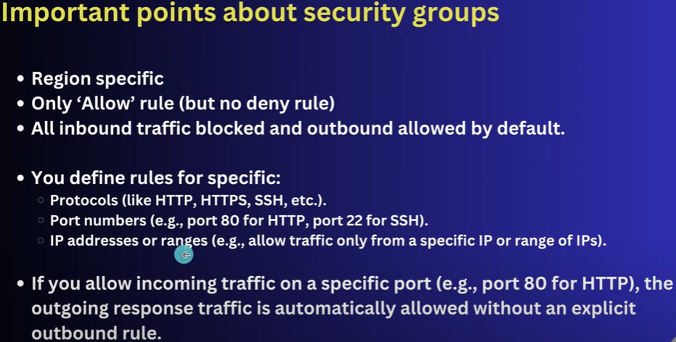

**AWS EBS(Elastic Block Store):**

When we create EC2 instance then we set storage that is basically the **EBS**

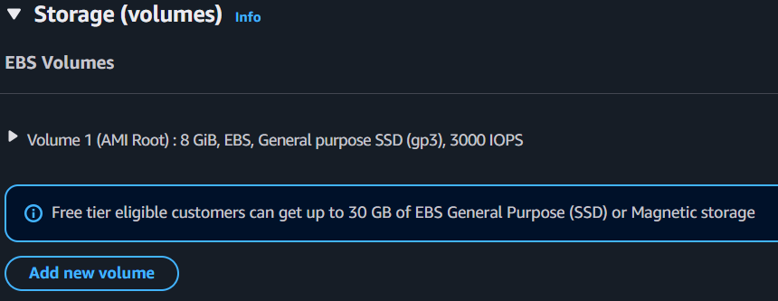

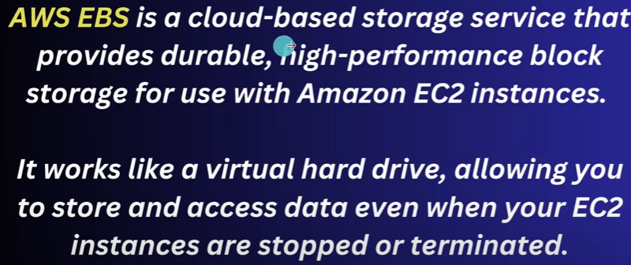

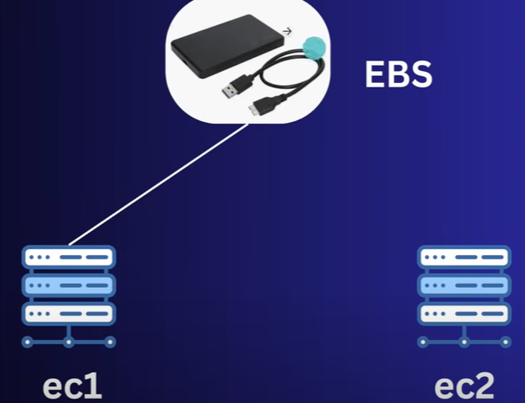

You can attached multiple EBS with single EC2 instance.

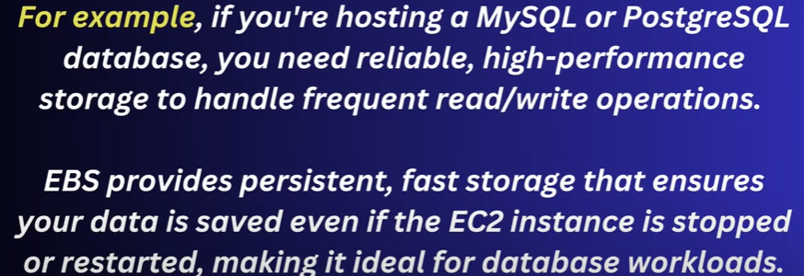

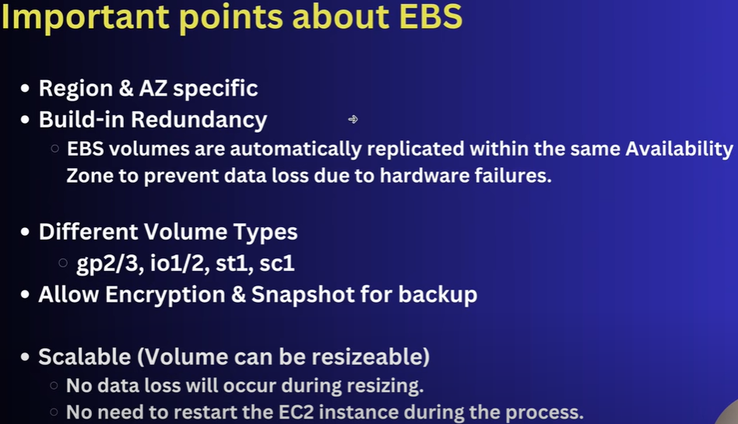

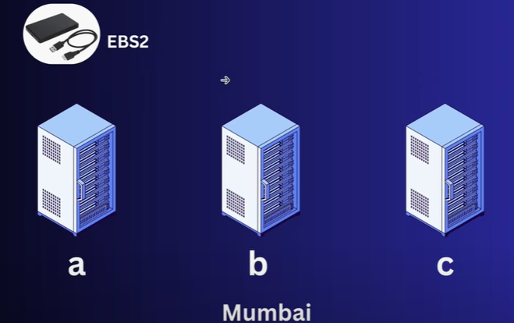

EBS is a region and availiability specific means suppose in mumbai region we have three zones **a, b, c**. Previoulsy EBS is present in zone **a** due to EC2 and then you create EC2 in zone **b** then you can access EBS created at zone **a**.

**lsblk:** It is a linux cmd used to show all the specified block devices (like hard drives, SSDs, partitions, USBs).

**Snapshot**

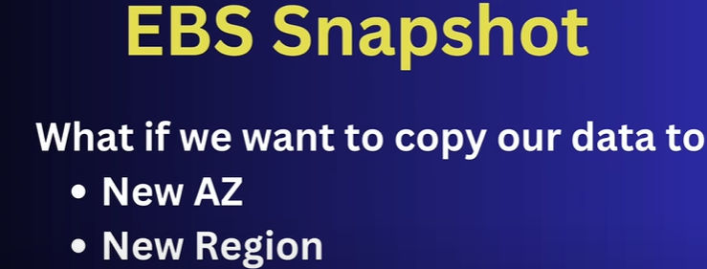

This is where you want to create instance at diff zone and EBS is present in diff zone, then using snapshot you can copy the data from EBS and store it in new EBS in diff zone which attch to EC2.

